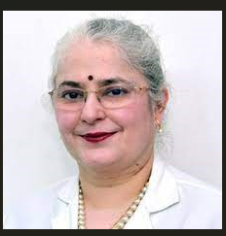

Dr. Subhadra Jalali, from India, did her MBBS from Govt. Medical College Jammu, Jammu and Kashmir State in 1986 and MS from PGI Chandigarh, in 1989. She completed two-year fellowship from LV Prasad Eye Institutr (LVPEI) in 1993, and further fellowships in USA in Ocular genetics, Visual Electrophysiology and Posterior Uveitis (1995) and in Retinopathy of Prematurity (1998).
Presently she is Consultant at LVPEI since 1993. She was amongst the first group of pioneering women in India to go for exclusive Retinal surgery practice that was an exclusive male domain at that time. She has over 800 presentations including orations and 200+ publications. Her current designation is Network Director of Quality and Network Director of Newborn Eye Health Alliance (NEHA). She is a Co-investigator in various multicentric international studies. She is the recipient of State, National and International awards including the AAO and APAO Achievement awards, ISCEV travel grant, P. Siva Reddy award to name a few. Her crowning glory is however the more than 350 fellows who have been trained by her in ROP from Mexico to Azerbaijan to Indonesia and Bangladesh besides all over India. She is known for setting up a city-wide ROP program, the first one in India and in most of the countries. She loves dancing and enjoying various cultures around the world. Her partners in this journey are her neurologist husband Dr. Subhash Kaul and two children, BIITSIANS Rishabh Kaul (belong.co) and Lucky Kaul.
Email:subhadra@lvpei.org; Phone: 9848995088

