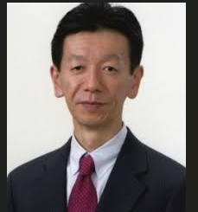

Biography of Shunji Kusaka, M.D.

After graduating Osaka University Graduate School of Medicine, he finished residency program at Department of Ophthalmology, Osaka University. After finishing a vitreoretinal fellowship at Osaka National Hospital, he became an assistant professor at Ehime University. Then, he joined a research fellowship program at University of Michigan to study the physiology of retinal glial cells under supervision of Donald G. Puro, MD., Ph.D. After coming back to Osaka University as an assistant professor, besides busy clinical work as a vitreoretinal surgeon, he continued basic research on RPE cell physiology, and has published so far several papers in prestigious basic science journals such as The Journal of Physiology, Glia, and IOVS. In addition, he has published over 130 clinical study papers. He has become a professor and chair at Department of Ophthalmology, Kindai University Faculty of Medicine since 2018. Currently, his main interests are surgical treatment of various vitreoretinal disorders, including pediatric retinal diseases, and basic research of pharmacological treatment of ocular neovascular diseases.

