**giyim, insan yüzü, kişi, şahıs içeren bir resim

Açıklama otomatik olarak oluşturuldu**

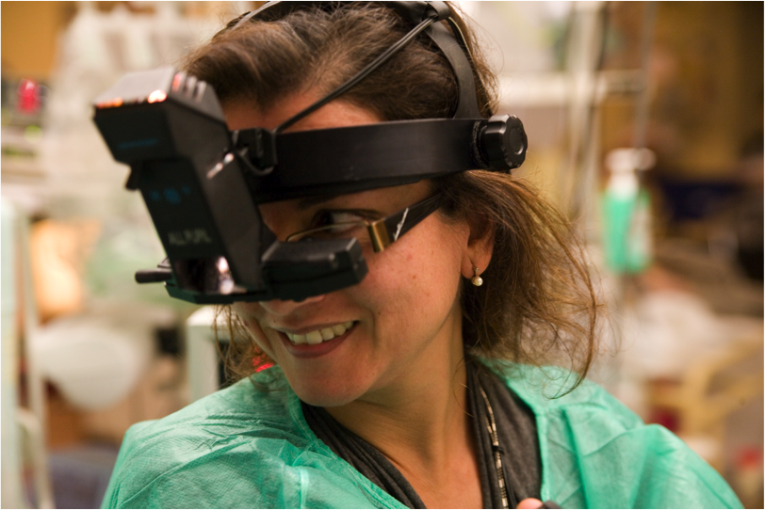**Curriculum Vitae**

**Name**: Susana Maria Pereira Teixeira

**Clinical Name**: Susana Teixeira

**Special Interests**:

Medical and Surgical Retina, Pediatric Retina, Ocular Trauma

**Professional Experience**:

Since December 1997: Ophthalmology Graduated Hospital Assistant working in Ophthalmology Service of Professor Doutor Fernando Fonseca Hospital (HFF) in Lisbon.

Since 1997 she is a member of the medical and surgical retina Department of HFF. She was responsible for surgical retina and pediatric retina section between 2005 and 2016. Since 2015 she collaborates in surgical retina section and is responsible for ROP section in HFF.

Since **1997 she implemented ROP Screening and Treatment** in Hospital Fernando Fonseca NICU where it is also provided ROP screen and treatment for babies from the NICUs of Lisbon, South Portugal, islands of Madeira and Açores. We also implemented telemedicine with some of those NICUs. In 2012 a joint project of Hospital Fernando Fonseca NICU and the pediatric retina department received a “Missão Sorriso Prize” and we could create a special room full equipped for the treatment of ROP in our NICU. During the year of 2006 she **implemented the use of antiangiogenic therapy** for neovascular diseases of the eye, namely diabetic retinopathy and ROP in Hospital Fernando Fonseca. We were one of the first in the world to use bevacizumab for the treatment of ROP and we have more than200 eyes of VLBWB treated with antiangiogenic therapy with 16 years of follow-up.

Since 2016 she develops her clinical activities between Hospital da Cruz Vermelha, Hospital Fernando Fonseca and Hospital Da Luz in Lisbon.

**Academics**:

Doctorate in Medicine in 1998 (1982-1988)

Medical in Hospital de Santa Maria, Lisbon (1988-1990)

Residency in Ophthalmology in Hospital de Santo António dos Capuchos, Lisbon (1991-1996)

Hospital Assistant Graduation in 1996

Hospital Consultant in 2005

**Teaching and Formative Activities:**

She is responsible for residents, participates in practical formation of students of Lisbon Medicine University, organizes formative lessons for General Medicine Clinicians and Pediatricians and PhD thesis advisor in ROP. Uses to organize and participate in national and international meetings.

She edited the Portuguese Society of Ophthalmology 2007 Monograph with the title of “Retinopathy of Prematurity”.

She is reviewer of the Ophthalmic Surgery, Laser and Imaging and **published the** **first paper about the use of bevacizumab in ROP (Ophthalmic Surg Lasers Imaging. 2007 May-Jun;38(3):233-7).**

**Participation in studies**:

National Coordinator for the Firefleye and Firefeye Next Studies

Principal investigator of Firefleye and Fireffeye Next in HFF

Lisbon, 25/05/2022